## Setup

library(sf)  
library(tidyverse)  
library(spdep)  
library(tmap)  
library(spatialreg)  
  
election <- read_sf("export/2004_Election_Counties.shp") %>%  
 st_transform(crs = st_crs("EPSG:2163"))  
  
centroids <- st_centroid(election)$geometry  
  
election_neighbors <- election %>%  
 poly2nb()  
  
election_weighted <- election_neighbors %>%  
 nb2listw(  
 style = "W",  
 zero.policy = TRUE  
 )

## Question 1:

Use lm() to estimate Bush_pct ~ pcincome using ordinary least squares (OLS). Plot the **residuals** on a map (look back to R Module 7) and **test the residuals for spatial autocorrelation**. Provide both an example of your map and the results from your spatial autocorrelation test in your R Markdown report.

lm <- lm(Bush_pct ~ pcincome, data = election)  
summary(lm)

##   
## Call:  
## lm(formula = Bush_pct ~ pcincome, data = election)  
##   
## Residuals:  
## Min 1Q Median 3Q Max   
## -63.434 -7.927 0.479 8.755 31.904   
##   
## Coefficients:  
## Estimate Std. Error t value Pr(>|t|)   
## (Intercept) 6.343e+01 8.893e-01 71.329 < 2e-16 ***  
## pcincome -1.592e-04 4.832e-05 -3.294 0.000997 ***  
## ---  
## Signif. codes: 0 '***' 0.001 '**' 0.01 '*' 0.05 '.' 0.1 ' ' 1  
##   
## Residual standard error: 12.74 on 3109 degrees of freedom  
## Multiple R-squared: 0.003479, Adjusted R-squared: 0.003158   
## F-statistic: 10.85 on 1 and 3109 DF, p-value: 0.0009974

election$residuals <- lm$residuals  
  
tm_shape(election) +  
 tm_polygons(  
 col = "residuals",  
 border.col = NULL,  
 style = "cont"  
 )

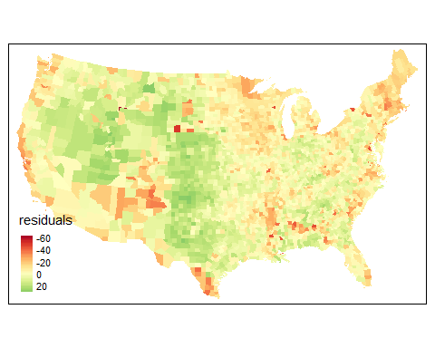

moran_residuals <-  
 moran.test(  
 x = election$residuals,  
 listw = election_weighted,  
 zero.policy = TRUE,  
 alternative = "two.sided"  
 )  
  
moran_residuals

##   
## Moran I test under randomisation  
##   
## data: election$residuals   
## weights: election_weighted n reduced by no-neighbour observations  
##   
##   
## Moran I statistic standard deviate = 51.138, p-value < 2.2e-16  
## alternative hypothesis: two.sided  
## sample estimates:  
## Moran I statistic Expectation Variance   
## 0.5501302998 -0.0003219575 0.0001158637

## Question 2:

Modeling Kerry_pct ~ pcincome, perform the following steps: - Evaluate the relationship between the variables using lm() - Plot the resulting residuals, then test for autocorrelation with moran.test(). Provide your map!

kerry_lm <- lm(Kerry_pct ~ pcincome, data = election)  
  
election$kerry_lm_res <- kerry_lm$residuals  
  
tm_shape(election) +  
 tm_polygons(  
 col = "kerry_lm_res",  
 border.col = NULL,  
 palette = "RdBu",  
 style = "cont",  
 midpoint = 0,  
 title = "Residuals"  
 )

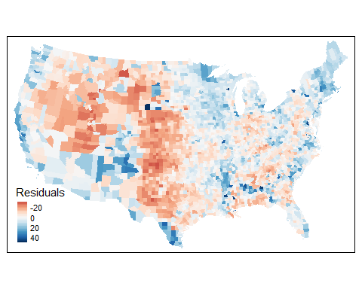

kerry_moran <- moran.test(  
 election$kerry_lm_res,  
 listw = election_weighted,  
 zero.policy = TRUE,  
 alternative = "two.sided"  
)  
kerry_moran

##   
## Moran I test under randomisation  
##   
## data: election$kerry_lm_res   
## weights: election_weighted n reduced by no-neighbour observations  
##   
##   
## Moran I statistic standard deviate = 51.382, p-value < 2.2e-16  
## alternative hypothesis: two.sided  
## sample estimates:  
## Moran I statistic Expectation Variance   
## 0.5527928269 -0.0003219575 0.0001158778

* Estimate the same relationship, using the spatial lag model (spatialreg::lagsarlm())

library(spatialreg)  
kerry_lag <- lagsarlm(  
 Kerry_pct ~ pcincome,  
 data = election,  
 listw = election_weighted,  
 zero.policy = TRUE  
)  
  
summary(kerry_lag)

* Perform a Moran’s I test on the residuals from the lag model and report your results. Plot the residuals from the spatial lag model, and include in your report.

election$kerry_lag_res <- kerry_lag$residuals  
  
tm_shape(election) +  
 tm_polygons(  
 col = "kerry_lag_res",  
 border.col = NULL,  
 palette = "RdBu",  
 style = "cont",  
 midpoint = 0,  
 title = "Residuals"  
 )

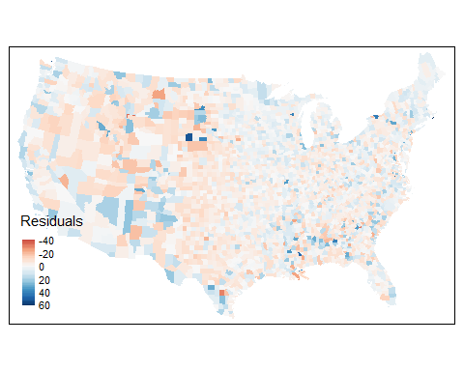

kerry_lag_moran <- moran.test(  
 election$kerry_lag_res,  
 election_weighted, ,  
 zero.policy = TRUE,  
 alternative = "two.sided"  
)  
kerry_lag_moran

##   
## Moran I test under randomisation  
##   
## data: election$kerry_lag_res   
## weights: election_weighted n reduced by no-neighbour observations  
##   
##   
## Moran I statistic standard deviate = -3.3346, p-value = 0.0008542  
## alternative hypothesis: two.sided  
## sample estimates:  
## Moran I statistic Expectation Variance   
## -0.0361970075 -0.0003219575 0.0001157424

* Is there evidence of remaining spatial autocorrelation in the residuals?

*No, as the value of I from the moran.test is close to 0, there is little remaining spatial autocorrelation.*

## Question 3:

Using your Kerry_pct ~ pcincome analysis, perform the spatial error model. Provide the results of the model and plot its residuals on a map. Then, perform Moran’s I on the resulting residuals, and provide the Moran’s I and p-value. Explain any differences in the values between: - The coefficient variables ( $λ$ and $ρ$), - The p-values in the spatial regression models, - The Moran’s I statistics, and, - The p-values from the Moran’s I

kerry_error <- errorsarlm(  
 formula = Kerry_pct ~ pcincome,  
 data = election,  
 listw = election_weighted,  
 zero.policy = TRUE  
)  
  
summary(kerry_error)

##   
## Call:errorsarlm(formula = Kerry_pct ~ pcincome, data = election, listw = election_weighted, zero.policy = TRUE)  
##   
## Residuals:  
## Min 1Q Median 3Q Max   
## -43.5561 -5.5679 -1.1063 4.4040 52.7563   
##   
## Type: error   
## Regions with no neighbours included:  
## 36 691 711 883   
## Coefficients: (asymptotic standard errors)   
## Estimate Std. Error z value Pr(>|z|)  
## (Intercept) 3.9847e+01 9.7530e-01 40.8563 <2e-16  
## pcincome -1.9955e-05 4.1196e-05 -0.4844 0.6281  
##   
## Lambda: 0.75979, LR test value: 1803.8, p-value: < 2.22e-16  
## Asymptotic standard error: 0.014301  
## z-value: 53.129, p-value: < 2.22e-16  
## Wald statistic: 2822.7, p-value: < 2.22e-16  
##   
## Log likelihood: -11389.23 for error model  
## ML residual variance (sigma squared): 77.035, (sigma: 8.7769)  
## Number of observations: 3111   
## Number of parameters estimated: 4   
## AIC: 22786, (AIC for lm: 24588)

election$kerry_err_res <- kerry_error$residuals  
  
kerry_error_moran <- moran.test(  
 election$kerry_err_res,  
 listw = election_weighted,  
 zero.policy = TRUE,  
 alternative = "two.sided"  
)

library(broom)  
options(pillar.sigfig = 5)  
  
  
# Regression Coefficients  
bind_rows(  
 tidy(kerry_lag)[1, ],  
 tidy(kerry_error)[3, ]  
)  
  
  
# Autocorrelation Coefficients  
  
moran_names <-  
 c(  
 "Moran's I",  
 "Expectation",  
 "Variance",  
 "Standard Dev.",  
 "p-value",  
 "Method",  
 "Alternative"  
 )  
  
  
tribble(  
 ~Model,  
 "Spatial Lag",  
 "Spatial Error"  
) %>%  
 bind_cols(bind_rows(  
 tidy(kerry_lag_moran) %>%  
 `colnames<-`(moran_names),  
 tidy(kerry_error_moran) %>%  
 `colnames<-`(moran_names)  
 ))